candidates’ guide 2014
contents

Welcome address from the Returning Officer 2
What is DSU? 3
The importance of student representation 4
Available positions 6
Executive Officers 7
Trusteeship in more detail 7
Job descriptions: 10
President 11
Deputy President Education 12
Vice President Media and Communications 12
Vice President Student Activities 13
Vice President Welfare 13

Student Representative positions 14
Black and Minority Ethnic (BME) Representative 15
Disabled Students’ Representative 15
International Students’ Representative 15
Lesbian, Gay, Bisexual and Transgender (LGBT)
Representative 16
Mature Students’ Representative 16
Media Representative 16
Part Time Students’ Representative 16
Raise and Give (RAG) Representative 16
Societies Representative 16
Sports Representative 16
Volunteering Representative 16
Women’s Representative 17
Open Place Representative 17

Chair of Student Council 17
The National Union of Students (NUS) 17
NUS Representatives 17
Elections timetable 17
What do I need to do? 19
Guidance for producing your manifesto 20
Guidance for producing your publicity 20
Campaigning 21
Budgets 22
Holding a position of responsibility 22
Dual positions 23
Voting system 23
Contacts 25
Elections regulations 25
Additional DSU guidance 26
Checklist 29

Appendices
Nomination form; Expenditure form; Example manifesto (Ian Warrington, the current President); Publicity suggestions; Equality and diversity monitoring form
Trustee form; Declaration of Convictions form; Staffing protocol
welcome address from the returning officer

Hi,

My name is Emma Powell and in my capacity as the NUS Head of Membership, I’m delighted to be the Returning Officer for De Montfort Students’ Union main elections.

Firstly, the serious bit... The role of the Returning Officer is extremely important. I ensure that the elections are conducted in a free and fair manner. This means that should you, another candidate or any student express a concern or complaint in relation to any aspect of the election process I am on hand to investigate this. This can be directly or through either the Deputy Returning Officer or the Election Official, individuals chosen to support these elections.

At times I may be required to make rulings based on activities as and when they take place, some of which aren’t too popular. Should this be the case, all candidates will be notified via email (although not necessarily informed of the reason behind my decision). It is therefore really important that you read this Guide carefully to prevent yourself from conducting your election campaign in a unsuitable manner. Please feel free to ask any questions to either myself, Victoria Hossack, the Deputy Returning Officer, or Colina Wright, the Election Official, our contact details can be found on page 25.

Now... I’d like to take this opportunity to thank you for your interest in these elections. It’s an exciting time for De Montfort Students’ Union - we are now looking at expanding the space (and potentially services) we have and the successful candidates will have an integral part of leading discussions with our membership.

Being involved in the Students’ Union as an elected representative, either full time or part time, can present a mixture of emotions; it’s exciting and challenging as well as being quite daunting initially. The skills and experiences gained during your time in office is unique, you’re given a direct role in the management and development of your Union, an experience generally gained in later life. These skills can be transferred to all walks of life so if considering your next step, this is certainly an opportunity worth thinking about.

The Students’ Union offers a safe and supportive environment to learn and to develop personally. There is a lot of support for elected Officers and Representatives. There are other Officers (both within your Students’ Union and across the country), the staff within your Union are a fantastic resources and there’s also me and other colleagues at the National Union of Students, available long after the election period is over, so don’t be put off standing for this once in a lifetime opportunity.

Additional information about the roles will be outlined in the “So you want to run the Students’ Union” session (further details can be found on page 18).

The Guide has been put together to (hopefully) answer any questions you have about the whole election process, from how to apply to explaining the voting system.

We’re here to ensure that the election process is fair but also enjoyable for all involved.

I wish you all the best in these elections and hope to see you at some point during this process.

Emma Powell
DSU Returning Officer / NUS’ Head of Membership
WHAT IS DSU?

“De Montfort Students’ Union is student-led and student focussed. We aim to represent, inspire and involve our members to enhance their University experience.”

We do this through our 5 core values:
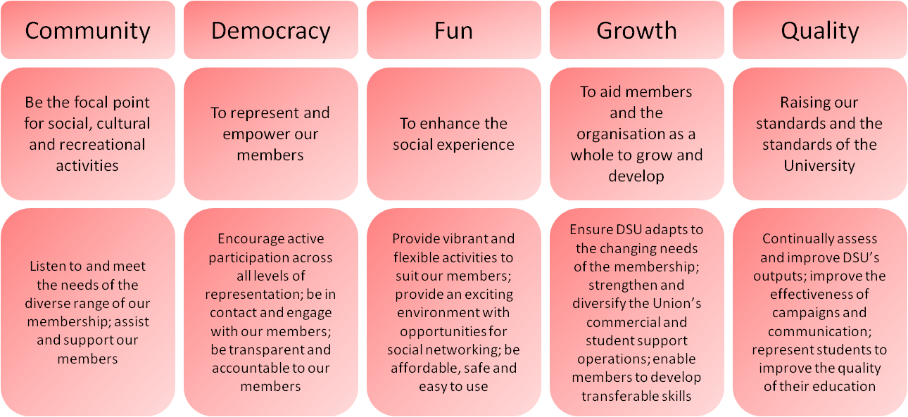

DSU is the recognised representative channel of the student body of De Montfort University (DMU), representing ALL students within the University, including full-time, part-time, distance learners, mature, international, postgraduate and research students.

The University’s Board of Governors regulates DSU, in terms of regulating the governing documents, and ensuring elections are free and fair. It also provides funding, in the form of a block grant. On day to day issues our interaction is with Senior University Management.

DSU is governed by the Board of Trustees, which is made up of the 5 elected Executive Officers, 4 Student Trustees and 4 External Trustees in accordance with the governing documents.

DSU has charity status and is one of the largest charities in Leicester. We are a limited company and our Trustees undertake the role of Company Directors.

DSU has turnover of around £1.6 million, employs around 95 staff and represents about 21,000 students. DSU employs staff to carry out the work of the Union. In conjunction with the President, the CEO is responsible for the day-to-day running of the organisation, reporting to the Trustees.

DSU exists to represent the student body. It does this in many forms, from the Executive Officers, Student Representatives, Faculty Reps and Course Reps. The Executive Officers, also known as the Executive Committee, represent the student body at the most senior level, including sitting on the University’s Board of Governors and Academic Board. The Executive Officers also run a series of campaigns, educating students on issues affecting them.

We also enhance the student experience through sports, DSU Volunteering, societies, media, and, in fact all the things outside of the lecture theatre that make being a student so enjoyable. DSU provides many ways for students to participate in, to enhance their student experience. DSU organises many events for students to get involved in, including the Varsity matches. Not forgetting the support offered by DSU Welfare which provides a free, confidential and independent advice centre to students. It deals with a wide variety of issues, including accommodation, immigration and academic offences.

We also have a number of commercial services which include catering, the DSU Shop, DSU Tech, our computer repair services, marketing and the nightclub. These exist to make money for the other areas of the Union, but play a key part in the student life, including the Freshers’ Fair, but most obviously through providing a friendly place for students to enjoy their time at University.

The Governing Documents has a section on staffing protocol meaning that the Exec shall not be involved in operational staffing issues – so don’t run for election if you want to run or manage our commercial operations.

THE IMPORTANCE OF STUDENT REPRESENTATION

Below is a diagram outlining the student representation within both the University and the Students’ Union:

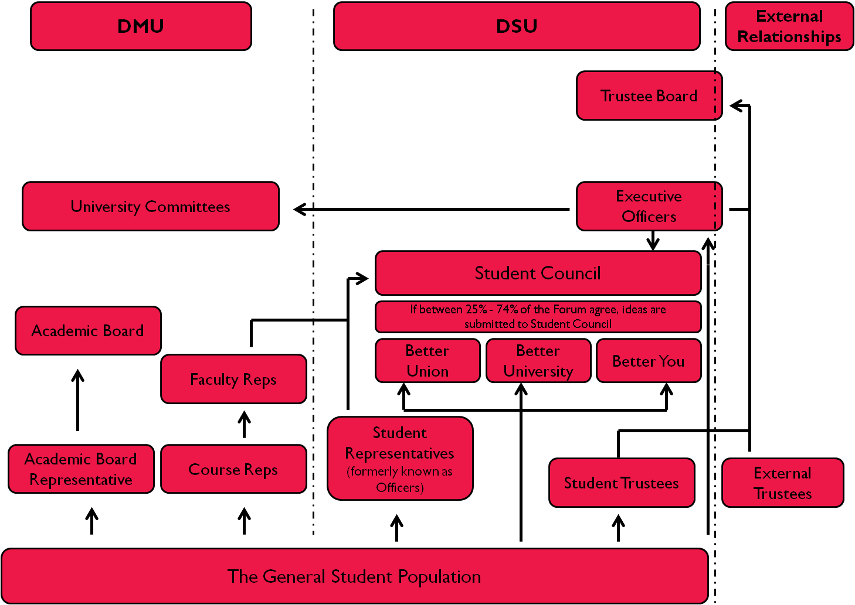

Taking the University side first…
The general student population | There are over 21,000 students at De Montfort University, including distance learners and those studying at a number of Collaborative Partner Colleges located around the country.
Course Reps | From the general student population, there are a number of Course Reps per course. These students are elected by the peers to represent students’ learning and teaching issues at course level. These elections take place within the first few lectures of the term.
Faculty Reps | Course Reps interested in getting more involved can choose by become Faculty Reps. As its name suggests, these individuals represent students’ issues at a Faculty level.
Academic Board Representative | One student from the general student population can choose to become the Academic Board Representative. This role is by application, chosen by the DSU Appointments Panel.
Academic Board | Academic Board is the highest level of representation that students are able to participate in.
University Committees | There are several meetings held within the University that the Executive Officers attend, representing the views of the 21,000 students at De Montfort.
Turning our attention to the Students’ Union side of the diagram…
Student Representatives | There are 16 Student Representatives each with a specific remit. Students belonging to those “communities” are entitled to stand these roles; a more detailed breakdown is provided within the individual job descriptions found on pages 15 – 17.
Executive Officers | There are five Executive Officer positions; these are paid, full time roles for the duration of a year. These include President, Deputy President Education, Vice President Media and Communications, Vice President Student Activities and Vice President Welfare. Students interested in fulfilling these duties either have to take a year out of studying or undertake this year immediately after their final year. These elections take place during the second term, usually around February / March.
Forums: Better Union, Better University, Better You | DSU have recently introduced a series of Forums (Better Union, Better University, Better You), each of which will take place twice a term;  - Better Union is about ways to improve services provided by the Union or your social experience  - Better University is about improving the student experience from an academic perspective  - Better You is about enhancing the opportunities for you to develop  These focus groups enable all students across the University to discuss their ideas with an appropriate Officer. All students are welcome to attend these meetings, the dates and notes of which are advertised online.
Student Council | The 16 Student Representatives and the Executive Committee sit on Student Council. Student Council discusses and decides on the policies the Union should adopt. Ideas submitted at the Forums may feed into Student Council discussions. It scrutinises the works of the Executive Committee and, to a lesser extent, the work of the Student Representatives.
The Trustee Board | The Trustee Board is made up of the Executive Committee, 4 appointed Student Trustees and 4 externally appointed Trustees. Student Trustees roles are by application, chosen by the DSU Appointments Panel.  Trustees take overall responsibility for the work that the organisation undertakes. They will focus the strategic direction of the organisation, ensuring that the Union creates and implements strategies that meet the objectives of the charity. Trustees will also agree plans and budgets and will hold the Chief Executive Officer to account for the delivery of the plans.

Available positions
The positions are available in these elections are the:
- Executive Officers:
  - President
  - Deputy President Education
  - Vice President Media and Communications
  - Vice President Student Activities
  - Vice President Welfare
- Student Representatives:
  - Black and Minority Ethnic (BME) Representative
  - Disabled Students’ Representative
  - International Students’ Representative
  - Lesbian, Gay, Bisexual and Transgender (LGBT) Representative
  - Mature Students’ Representative
  - Media Representative
  - Part Time Students’ Representative
  - Raise and Give (RAG) Representative
  - Societies Representative
  - Sports Representative
  - Volunteering Representative
  - Women’s Representative
  - Open Place Representative
- Chair of Student Council
- NUS Representatives

Desirable personal qualities

All candidates should display the following qualities:

- Willing to show unrivalled dedication and commitment to the Union.
- Willing to work above and beyond the call of duty, including staying away from home for short periods of time e.g. for conferences, training etc. and working long days / weekends when required.
- Be enthusiastic, even when under pressure.
- Have an interest in student issues, both within the Union and nationally.
- Be willing to support decisions made in the best interests of the Union as a whole, even if you personally disagree with them.
- Have exemplary people skills, including public speaking and speaking to different levels of people.
- Be able to maintain confidentiality
- Be organised and able to work effectively and efficiently.
- Be trustworthy, reliable and a good timekeeper.
- Have an understanding of finance, and be willing to make decisions in the best interest of the Union
- Be able to work effectively in a team and help other team members in areas that do not necessarily fall within your own portfolio.
- Have a desire to make the Union better for all its members.
- Be willing to work with the University to ensure effective student representation.
- Be driven and passionate about the Students’ Union.

EXECUTIVE OFFICERS

There are five full time positions available for election. The remuneration (payment) for these posts will be c£16,700. Executive Officers have 20 days annual leave, not including the statutory and extra days.

In order to be eligible to stand in the elections you must be a student at DMU as defined by the University and Union regulations; these require you to be formally enrolled on a programme of study provided by the University and to have paid or had paid on your behalf the appropriate tuition fees.

There’s more to being an Executive Officer that simply undertaking the portfolio duties. NUS have stated that the role of an Executive Officer can be divided into four distinct areas, PARTs, these are not necessarily equal splits or mutually exclusive but you should be aware of these:

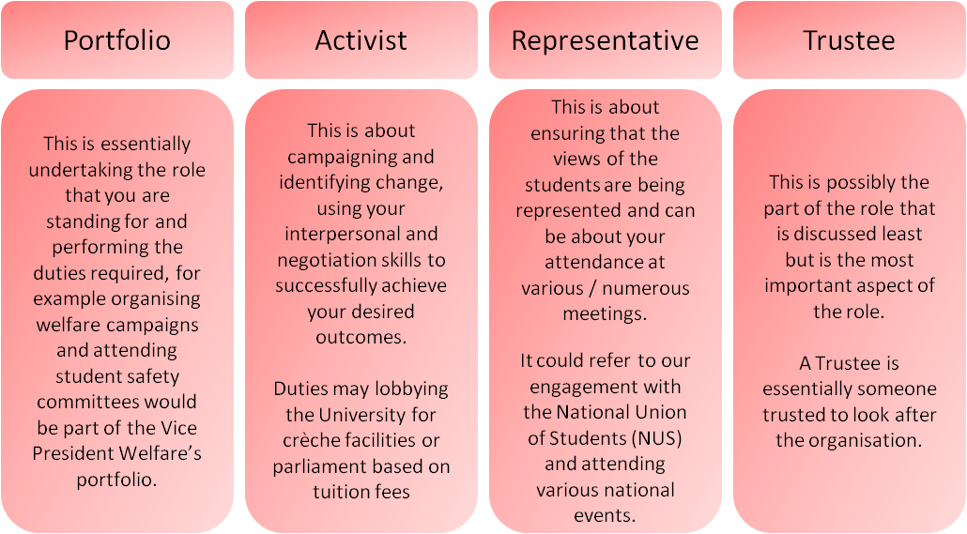

trusteeship in more detail
Our Trustees will take overall responsibility for the work that the organisation undertakes. They will focus the strategic direction of the organisation, ensuring that the Union creates and implements strategies that meet the objectives of the charity. Trustees will also agree plans and budgets and will hold the Chief Executive Officer to account for the delivery of the plans.
Trustees will be legally responsible for ensuring that the Union operates to standards set by parliament and the Charity Commission. In addition, the Union aspires to operate to good or best practice standards in these areas.
The Executive Officers as well as appointed Student and external Trustees (totalling 13 people) are responsible for the recruitment, appraisal and development of the CEO (although this is primarily undertaken by the Chair of the Trustees, the President).

Other duties of a Trustee include legal compliance, ensuring that the organisation has effective governance and is accountable and transparent. It involves making sure the organisation is financially sound and that you understand the figures, monitoring and managing risk... All this sounds daunting but you will be supported throughout the entire process and it’s an amazing experience that not many people ever get. In some cases, undertaking the less exciting tasks associated with being a Trustee are the areas in which you learn most about yourself and that can provide more tangible examples to enhance your CV.

As a Trustee there are additional stipulations that may impact on your eligibility. Below is a list of circumstances which may prevent you from becoming a Trustee (and standing for an Executive Officer position). You are not allowed to be a Trustee if you:
- Are less than 18 years of age
- Have been convicted at any time of any offence involving deception or dishonesty, unless the conviction is legally regarded as spent
- Are an un-discharged bankrupt
- Have made compositions with your creditors and have not been discharged
- Have at any time been removed by the Commissioners or by the Court in England, Wales or Scotland from being a Trustee because of misconduct
- Are disqualified from being a company director
- Have failed to make payments under the county court administrators’ orders.

If you are in any doubt about your eligibility to act as a Trustee you should either seek your own legal advice or contact the Charity Commissioners.

In addition you:
- Must not have held office as a DSU Executive member before for more than one term of office.
- Must be able to work for the Union for one year, from 1st July 2014 to 30th June 2015; however there is a period of handover usually in mid June during which time successfully elected Executive Officers will participate in training activities and attend a residential. We appreciate that this potentially coincides with Glastonbury and possibly other commitments however we ask that Officers are present throughout the whole of this period as it can be quite difficult to re-arrange certain events.

Don’t worry, we’re not expecting you to have any previous experience of operating as a Trustee (or any other role for that matter); during handover the Trustee aspect of the role will be covered in a lot more detail and you’ll earn about the other facets to the job as you go along.

As Trustees, Executive Officers have ultimate responsibility for the Students’ Union.

Executive Officers are the strategic lead in their area.

Each Executive Officer has responsibility for the development and implementation of their area’s strategy within the Union and in the wider University context.

The following information is dedicated to the duties of a Trustee as this is particularly important. After this you will find a generic job description for each Officer to undertake followed by a specific of the job description which has been broken down into each of the areas mentioned above.
COMMITMENT
The Trustee Board will meet four times a year, the duration of this meeting is subject to the agenda items requiring discussion but unlikely to last more than 2 hours.
In addition to these meetings, it is expected that Trustees will make time to read papers in preparation for meetings, be aware of developments within the sector and visit the Union occasionally to ensure that they are aware of key issues affecting the Union’s operations.
From time to time, the Trustee Board may establish ‘task and finish groups’ for finite periods to explore issues of importance. In addition, the Trustee Board may convene for strategic planning sessions for an away day each year.
The meetings scheduled for next year are:
- Tuesday 3rd June – (budget review) 4pm-6pm
- Tuesday 24th June – Away day 10am-4pm
- Tuesday 28th October – Auditors – 4pm
The locations will be communicated to the successful candidates.
KEY RESPONSIBILITIES
The Trustee Board will be responsible for:
- Ensuring that the Union has a clear vision, mission and strategic direction and is focussed on achieving these.
- Ensuring the performance of the Union and for its ‘corporate’ behaviour.
- Ensuring the Union complies with all legal and regulatory requirements.
- Acting as guardians for the Union’s assets, ensuring they are secure, and properly applied.
- Ensuring the Union’s governance is of the highest possible standard.
- Working in partnership with other trustees, the CEO and other senior staff members.
DUTIES
- To agree the vision, mission and strategic plan for the Union after consultation with the membership.
- To ensure that the operational and strategic plan reflect the agreed strategic direction.
- To agree measures for monitoring the implementation of plans.
- To hold the CEO accountable for the achievement of the organisation’s goals and provide regular constructive feedback on both management and overall achievement.
- To ensure that the Union has satisfactory financial controls in place and to review the Union’s risk register.
- To safeguard the Union’s reputation and other intangible assets.
- To reflect annually on the Board’s performance and your own performance as a Trustee.

TASKS
- To attend quarterly trustee meetings, read relevant papers and be prepared to make an active contribution.
- To participate in the annual strategic planning workshop.
- To support staff and student trustees when requested; sharing expertise as a member of a ‘task and finish’ group or in other ways.
- To network and promote the work of the Union.
job descriptions
All Executive Officers have a duty to fulfil the following for each discipline:
Trustee
- Complete a Trustee induction programme at the commencement of office.
- Act as a Trustee of the Students’ Union, giving full consideration to the needs of the whole organisation at all times.
- Ensure that De Montfort Students’ Union complies with all legal and regulatory requirements.
- Safeguard and protect the assets of the organisation.
- Ensure that the governance of the Students’ Union is of the highest possible standard and fit for purpose.
- Act collectively (decisions and responsibilities are shared).
- Act in interest of all students, despite specific portfolio responsibilities.
Portfolio
- Be responsible for managing budgets, where necessary and appropriate.
- Carry out all roles in liaison with relevant staff and fellow officers.
- Carry out other reasonable duties, as required by the Board of Trustees and/or the Executive Committee.
Representative
- Uphold and abide by the Memorandum and Articles of Association, the Bye-Laws and policies of the Union.
- Represent the views of the student body in appropriate forums.
- Actively solicit the opinions of the student body to ensure that representative activities meet the needs and reflect the views of the membership.
- Submit a report as and when required or when requested to general meetings of the Charity and Student Council.
Activist
- Engage with students and encouraging participation.
- Campaign on issues of importance to the student body.
- Actively solicit the opinions of the student body to ensure that campaigning activities meet the needs and reflect the views of the membership.
Personal
- Maintain good working relationships with your fellow Executive Officers.
- Be able to offer and receive constructive criticism.

THE PRESIDENT
Portfolio
- Take a lead in the production, revision and monitoring of the Students’ Union strategic plans.
- Have responsibility for staffing issues, in accordance with Schedule 6 of the Bye-Laws.
- Receive all Union complaints, and act on them in accordance with Schedule 7 of the Bye-Laws.
- Be responsible for financial and budgetary matters, and reporting them to the Board of Trustees.
- Ensure the Board of Trustees and Executive Committee communicate with a uniform voice, and make Members, members of Student Council, Executive and Student Representatives aware of their (collective) obligations and responsibilities.
- Chair the Board of Trustees, Executive Committee and general meetings of the Charity.
- Be aware of all major activities, developments and communications that are taking place within the Students’ Union, particularly from Executive Committee.
- Monitor that all actions and decisions from meetings are carried out, and report back on progress.
- Oversee the convening of the Board of Trustees, Executive Committee, Student Council and general meetings of the Charity, in accordance with the Memorandum and Articles of Association and/or the Bye-Laws.
- Be responsible for policy implementation and ensuring that the policy file is maintained.
- Be responsible for ensuring that affiliations to outside bodies, which are approved by the Executive Committee, are recorded in the appropriate manner.
- Convene Student Council meetings.
- Hold ex-officio membership of all Students’ Union sub or delegated committee meetings
Representative
- Act as the primary liaison between the Students’ Union and NUS
- Act as officer liaison between the Students’ Union and NUSSL
- Act as the delegation leader at NUS Conference, except where excluded by conference rules, and ensure delegates are aware of their obligations, responsibilities and Union policy.
- Be a member of all committees to which the role is entitled, including the University Board of Governors and Academic Board.
- Ensure that there is a Union Officer on all University disciplinary and appeal hearings.
- Act as the first cheque signatory.
Activist
- Be responsible for Union strategy, strategic planning and development, and researching best practice.
- Hold the authority to make emergency decisions on behalf of Executive and/or Board of Trustees, in situations where it cannot be convened, but report and ensure that such decisions are ratified immediately following meeting of the Executive or Board of Trustees.
- Act as the interpreter of the Memorandum and Articles of Association of the Charity, as and when required
For Ian’s perspective on his role, please see his video on YouTube... or speak to him!
DEPUTY PRESIDENT EDUCATION
Portfolio
- Be responsible for all issues pertaining to education within the Students’ Union, except for dealing with individual casework.
- Have strategic responsibility for Course Representatives and structures.
- Act as a conduit for information from the Students’ Union to Course Representatives.
Representative
- Delegate for the President in their absence where necessary / appropriate.
- Act as the main representative on academic issues to the University.
- Act as the primary liaison between the Students’ Union and students studying at Collaborative Partner Colleges.
- Be a member of all committees to which the role is entitled, including Academic Board.
- Act as the second cheque signatory.
Activist
- Be responsible for the development, implementation and revision of educational strategy within the Students’ Union.
- Have responsibility for all educational and academic campaigns and related events and be actively involved in the delivery of them at all sites.
For Caitlin’s perspective on her role, please see her video on YouTube... or speak to her!
VICE PRESIDENT MEDIA AND COMMUNICATIONS
Portfolio
- Undertake a regular review of the Students’ Union’s communication strategy to ensure that DSU’s key messages are communicated to the membership.
- Develop the professional production and relevant distribution of all Union media within the Students’ Union and the University.
- Have responsibility for the following:
  - Demon FM: Station Controller
  - Demon TV: Station Controller
  - Demontfortstudents.com: Website Controller
  - The Demon: Editor-in-Chief
- Be responsible for the production, editorial control and content of the annual Students’ Union Handbook.
- Coordinate all press releases, on behalf of the President, Executive Committee and Board of Trustees.
- Facilitate the recruitment and training of volunteers to assist in the delivery of Union media.
- Ensure members of the Board of Trustees are aware of all press briefings
- Oversee all Union media content.
Representative
- Be DSU’s principal representative to SRA (Student Radio Association) and NaSTA (National Student Television Association)
- Communicate DSU’s activities to community groups.

Activist
- Be responsible for the development and strategy of all media and communication tools within the Students’ Union.
- Lobbying against prohibitive communicative measures for students.
- Implementing new communicative devices to encourage engagement from the electorate.
For Alice’s perspective on her role, please see her video on YouTube ... or speak to her!
VICE PRESIDENT STUDENT ACTIVITIES
Portfolio
- Actively promote and encourage all students to get involved in their Union, particularly students who are currently under-represented within the Students’ Union’s activities and Students based off campus.
- Facilitate and encourage a diversity of activities and opportunities for students to be involved with.
- Be involved in the promotion, support and development of sports and societies.
- Chair the RAG committee, and facilitate its programme.
- Take strategic responsibility for Raise and Give, (“RAG”) and University sporting events (“Varsities”)
- Take responsibility for liaising with and co-ordinating clubs and society leaders and office holders
Representative
- Act as the liaison between the Students’ Union and the University’s Alumni scheme.
- Be the Students’ Union’s main representative to British University and Colleges Sports, (“BUCS”).
- Be the main representative for Union organised annual tours
Activist
- Be responsible for the development and strategy of student activities within the Students’ Union.
- Assist in the development and delivery of Union campaigns.
For Chris’ perspective on his role, please see his video on YouTube ... or speak to him!
VICE PRESIDENT WELFARE
Portfolio
- Co-ordinate all welfare campaigns and related events and be actively involved in the delivery of them at all sites.
- Be responsible for all issues pertaining to welfare within the Students’ Union, except for dealing with individual casework.
- Be responsible for the promotion of all elections and other democratic functions of the Students’ Union, in accordance with Schedule 3 of the Bye-Laws.
- Maintain relationships with key partners who are able to support the Students’ Union’s welfare activities
Representative
- Be responsible for building and maintaining positive relations with the local community and community organisations.
- Be a member of all committees to which the role is entitled, including Admissions Committee.
- Act as the main representative on welfare issues to the University.
Activist
- Facilitate and promote the awareness of support and community mechanisms and opportunities for students, such as through the Community Fair during induction week.
- Be responsible for the development, implementation and revision of the welfare strategy within the Students’ Union.
For Sarah’s perspective on her role, please see hers video on YouTube... or speak to her!

STUDENT REPRESENTATIVE POSITIONS
The diagram below shows which Officer has responsibility for which Representatives:

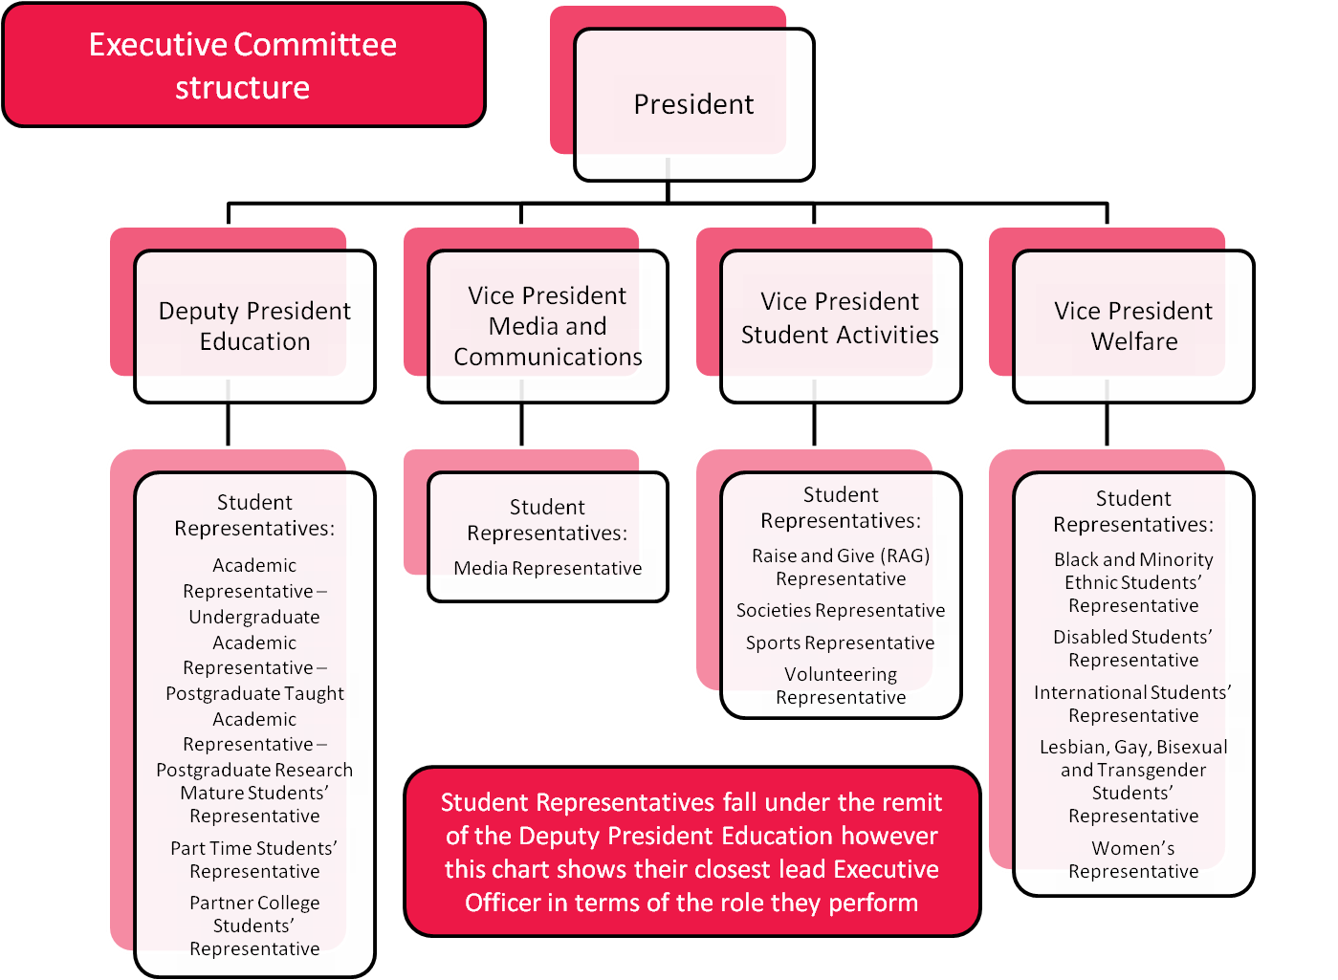

There are 16 Student Representative positions at DSU however a selection of these will be elected at a later point in the year. These are:

- Academic Representative – Undergraduate: the person undertaking this role has to be a Faculty Rep and these elections take place in the first academic term
- Academic Representative – Postgraduate Taught: the person undertaking this role has to be accepted on a postgraduate taught course and hosting these elections in October gives us more opportunity to engage as many students as possible
- Academic Representative – Postgraduate Research: the person undertaking this role has to be accepted on a postgraduate research course and hosting these elections in October gives us more opportunity to engage as many students as possible
- Partner College Representative: the person undertaking this role has to be topping up their degree and these students won’t start until September but are not likely to be known to us until later in the year.

Further information about each of the available roles is listed below.

Student Representatives are advocates for their area within the Union.

Student Representative often represent traditionally underrepresented groups; these positions exist to ensure that the Union considers the needs of all students in all its thinking and activities.

Student Representatives are activists.

They advance certain agendas and help the Union put on a more holistic offering both in terms of representation and activities.

Student Representatives, as part of Student Council, hold the Executive to account.
All Student Representatives have a duty to do the following:
- Attend and be a member of Student Council.
- Provide a report in advance of each Student Council meeting of their activity.
- Attend related training events and conferences (support provided by Students’ Union).
- Contribute to the strategic development of Students’ Union relative to the position held.
- Source student opinion to generate ideas relevant to students’ needs.
- Promote the positive involvement of the student community within Students’ Union.
- Inform, where appropriate, students on Students’ Union services and campaigns.
- Work alongside relevant Executive Officers.
- Work, where applicable, with a specific society to encourage participation.

More specific information about each of these roles available within this election is listed below:

Black and minority ethnic (BME) STUDENTS’ REPRESENTATIVE
- Must self define as belonging to the following communities: African, Arab, Asian or Caribbean
- Be aware of DSU / DMU’s provision for students of various ethnicities.
- Assist with campaigns specific to diversity issues.

DisablED STUDENTS’ REPRESENTATIVE
- Must self define as having a disability
- Liaise, where necessary, with relevant campaigning organisations and distribute material where appropriate.
- Be aware of DSU/DMU’s provision for disabled students.

International Students’ REPRESENTATIVE
- Must be an international student
- Work towards increasing participation of international students within DSU.
- Actively promote DSU services, in particular DSU’s Welfare and Education Centre (WEC) to international students.

Lesbian, Gay, Bisexual and Transgender (LGBT) REPRESENTATIVE
- Must self define as belonging to the LGBT community
- Liaise, where necessary, with relevant campaigning organisations and distribute material where appropriate.
- Work with the LGBT Society Committee.

Mature Students’ REPRESENTATIVE
- Must be registered as a mature student at DMU; a student over the age of 21 at the start of their course
- Work towards increasing participation of mature students within DSU.

Media representative
- Must be a registered Demon Media member
- Represent and be aware of the issues facing the DSU student media strands
- Be aware of Students’ Union’s Communication Strategy, Communication Policy and the Memorandum and Articles of the Charity and the Bye-Laws.
- Increase the profile and engagement levels of the DSU media strands

part time students’ representative
- Must be a part time student
- To be aware of and represent the issues and views of part time students
- To campaign on issues and make positive change for part time students

raise and give (RAG) representative
- Must be a registered DSU Volunteer
- Be the Vice Chair of the RAG Committee
- Actively promote RAG and its events through appropriate channels.
- Be aware of charity law, the Students’ Union’s RAG Constitution and Students’ Union Bye-Laws and Memorandum and Articles of Association of the Charity

societies representative
- Must be a registered society member, engaged in at least one society
- Publicise Students’ Union societies and encourage student participation.
- Work with relevant staff members to ensure all health and safety regulations are adhered to within societies.
- Can attend society committee meetings in an ex-officio capacity.

sports representative
- Must be a DSU active card holder
- Publicise Students’ Union sports clubs and encourage student participation.
- Work with relevant staff members to ensure all health and safety regulations are adhered to within sports clubs.
- Can attend sports clubs’ committee meetings in an ex-officio capacity.

volunteering representative
- Must be a registered DSU Volunteer
- Be chair of the Student Volunteering Committee
- Be aware of student volunteering sissies and represent these accordingly within the Students’ Union and University
- Increase awareness and impact of Student Volunteering Opportunities in the of Students’ Union.

Women’s REPRESENTATIVE
- Must self define as a female.
- Assist with campaigns specific to women.

open place representative
- To campaign and lobby on the key issues by which they were elected.

CHAIR OF STUDENT COUNCIL
Student Council would comprise of the above listed Student Representatives, the 5 Executive Officers and any students wishing to observe these.
Student Council would meet twice per term; the duration of this meeting is approximately 2½ - 3 hours, subject to the agenda.
The Chair of Student Council would have the main responsibility for convening Student Council (although any member can request meetings). They would require an understanding of the items for discussion on the agenda, which might include consultation with the appropriate person(s). The Chair would ensure that these meetings run smoothly and would ensure that all participants were given the opportunity to contribute and where treated with respect.
THE NATIONAL UNION OF STUDENTS (NUS)
WHAT IS THE NATIONAL UNION OF STUDENTS?
The National Union of Students (NUS) is one of the largest student organisations in the world, representing the interests of around five million students in Further and Higher Education throughout the United Kingdom. It is a voluntary membership organisation made up of local student representative organisations that have chosen to affiliate and pay a membership fee. NUS boasts nearly 750 constituent members (CMs) - virtually every college and university in the country, and De Montfort University Students’ Union (DSU) is one of the larger CMs.

NUS provides research, representation, training and expert advice for individual students and Students' Unions. They deal with over 15,000 welfare enquiries each year and train over 3,000 Students' Union Officers.

The work of the NUS is carried out by a combination of elected representatives and staff members, much like how an individual Students’ Union would operate. The National Executive Committee is comprised of 27 elected members fulfilling both full time and part time roles. The elections take place at the Annual Conference which is Tuesday 8th April – Thursday 10th April; these dates are during the Easter vacation.

NUS also host a series of smaller events throughout the year including portfolio specific events, eg. LGBT Conference, Black Students’ Conference, Women’s Conference but also regional receptions. The successful candidates will have an opportunity to represent DSU at appropriate meetings throughout the year. We appreciate that it may not always be possible to attend these events but DSU want to ensure that we actively participate in NUS activities.

Further information about the NUS Conference will be communicated to the successful candidates nearer the time. Information from the previous year’s Conference, along with generic information about NUS, can be found at www.nusconnect.org.uk; registration may be required to access this site.

NUS REPRESENTATIVES
DSU sends 6 Representatives to the NUS Conference - 3 Executive Officers (2 incoming and 1 outgoing) and 3 students. NUS Conference is an opportunity to discuss the direction NUS takes in the coming year, debating policies and electing Committee members; these positions are for students with a wider interest in student politics and campaigning.

Election Timetable

Nominations open Thursday 9th January, 10am
So you want to run the Students’ Union?
Monday 13th January, 4.30, the Lobby
This session give participants a deeper insight into how the Students’ Union is run, the mission and values of the Union and its functions from the perspective of one of the current Officers. You will have the opportunity to ask questions about the roles and explore some of the fears about standing in the elections.
Attendance is not compulsory.

Nominations close Friday 24th January, 4pm; at this point you are only required to submit your nomination form
Manifestos and additional materials required by
Wednesday 29th January, midday
Candidates’ briefing (1) Tuesday 4th February, 5pm, DSU Meeting Room
(2) Wednesday 5th February, 12pm, DSU Meeting Room
Attendance at one of these meetings is compulsory; you may send a representative in your place should neither time be suitable. Failure to attend / send a representative will mean your withdrawal from the elections.

Candidates’ question time
Wednesday 5th February, 2.30 onwards, the Food Court

Attendance at this meeting is compulsory. Failure to attend will mean your withdrawal from the elections.

The launch event Thursday 6th February, 11am – 4pm
Voting opens Thursday 6th February, 10am

Breakfast with the Candidates Monday 10th February, 10.30 – 11.30, Level 1
This is another opportunity to speak to any students present. Breakfasts will be provided to the first 50 students in attendance. This is not compulsory but advantageous, as the candidate, you will be entitled to a free breakfast too.

Demon Media
Demon Media would also like to give you the opportunity to have a live debate with your fellow candidates. Dates for this are:
Friday 7th February, 1pm, the Venue: Deputy President Education, Vice President Media and Communications, Vice President Student Activities
Monday 10th February, 1pm, the Venue: President, Vice President Welfare

Voting closes Wednesday 12th February, 10pm
Candidates’ breakfast Thursday 13th February, 10.30am, The Venue
Results announced Thursday 13th February, afternoon – the exact time is to be confirmed, The Food Court
(* subject to the receipt of any complaints)
There will be daily catch ups with refreshments from Friday 7th February at 10am in the Lounge, this will be your opportunity to raise any issues and to receive any voting updates. Ideally someone from your campaigns team should be in attendance, if not you.

What do i need to do?
To stand in these elections you will be required to:
- Complete and return an electronic nomination form by Friday 24th January, 4pm. This also has to be returned as a hard copy – the form is towards the back of this Guide.
This needs to be completed by you with the details of two additional students (your proposer and your seconder – these students simply agree that you should stand in these elections); these students can also be standing in the elections but cannot be current Officers or members of staff within the Union or University.

PLEASE NOTE: YOU WILL NOT BE ABLE TO STAND IN THE ELECTIONS SHOULD YOU NOT RETURN YOUR NOMINATION FORM BY THIS DEADLINE.

- Submit an electronic copy of your manifesto online and also ensure that an electronic copy is submitted to Colina (ccwright@dmu.ac.uk), along with other documents by midday on Wednesday 29th January:
  - Your Trustee declaration form (if you’re standing for an Executive Officer role)
  - Your equality monitoring form
  - Your poster design (you are responsible for printing and distributing your publicity however no publicity can be printed prior to approval)
  - Content for online publicity or text messaging.
- If you have not included a photo on your manifesto and would like one, please submit this too. This doesn’t have to be passport style photo, it can be any photo, including ones from Facebook.

Your manifesto should outline your intentions for the role within the year and why you think people should vote for you. You can provide personal information too. An example has been included in the Guide and although current Officers and staff can help you think of what you might like to consider, we are unable to help you write this. The word limit for your manifesto is 300 words, manifestos exceeding this will be edited without consultation.

- Attend one of the Candidates’ Briefings (Tuesday 4th at 5pm or Wednesday 5th February at 12pm). These will take place in the Students’ Union meeting room. Attendance is compulsory. If you are unable to attend you must inform one of the Election personnel and send a delegate in your place.

- Attend the Candidates’ Question Time, Wednesday 5th February, from 2.30pm, the Food Court. Attendance is compulsory.

- Record a video manifesto, should you wish. Your video should last no more than 3 minutes and should tell people details of how and when to vote, as well as outlining your manifesto. Time slots will be communicated to the candidates.

- This year there will be daily Candidates’ Catch-ups taking place in either the Lounge or the Meeting Room from 10am. These are not compulsory but we would strongly advise you (or a representative) to attend. During these briefings you will be given overall vote cast and any information regarding changes to election proceedings; this is also an opportunity to highlight any obstacles you’ve encountered or issues before these become complaints, giving the Election Officials adequate time to investigate any issues and provide a response.

- Attend other campaigning opportunities mentioned above including The launch event, Breakfast with the Candidates and the Demon FM broadcasts, if possible.

guidance for Producing your manifesto
Things to consider when writing your manifesto:
- Don't talk about other candidates.
- Do not make promises that you are unlikely to be able to keep.
- Do not make promises that relate to areas outside of the remit of your area.
- You can mention any involvement you've had in the University and/or Union.
- You can mention your skills, knowledge and experience.
- You should talk about what you would like to do once elected.
- Try and use plain English and be clear and concise.

Online manifestoes
Your manifesto can be automatically uploaded however you will need to ensure that an electronic copy is sent to Colina to ensure that booklets can be produced.

You will have the choice to have your photo attached to your manifesto, but it is something to consider as voters will be able to recognise you.

GUIDANCE FOR PRODUCING YOUR PUBLICITY
It is your choice what your publicity looks like however you might want to consider some of the following:
- Your publicity should clearly state your name and the role you are running for
- It should also inform students how to vote (once DSU received your nomination, you will be sent an official image that should be put onto your printed resources. If this is not on your publicity, it can be removed)
- It could be simple and include a slogan associated with your campaign
- It could be an edited version of your manifesto, highlighting the important issues
- It could include your photo
- It should include the DSU Official Elections stamp which is available online; publicity that does not include this will not be approved but if displayed, will be removed by Estates.

There is a wealth of information that can be found online about campaigning, NUS is a good place to start. Alternatively you could also type the names of specific Unions such as the University of Lincoln Students’ Union, Loughborough University Students’ Union.

The following are examples have been uploaded onto YouTube from other Students’ Union’s elections:
- “Smurf” for Activities, University of Nottingham Students’ Union, http://youtu.be/R6vueIYLdb0
- “Corcky” for President, University of Nottingham Students’ Union, http://youtu.be/cOf0qh1aJWw
- Andrew “Banjo” Wilkins for Student Activities, Nottingham Trent Students’ Union, http://youtu.be/q_LWZSnoBJE
- “Vote Kate and Liz”, Nottingham Trent Students’ Union, http://youtu.be/WSe_UxPYmWo
- Dan Sam, Student Activities, University of Lincoln, http://youtu.be/DRuZ3v1JsD4

There are hundreds out there to look at though and you don’t have to be a whizz-kid to plan something effective.

We have also included examples of previous elections publicity in the appendices.

Campaigning

Campaigning is vital, not only will it gain you the votes you require to get elected, but the greater number of votes, the greater influence you will be able to wield in your time in office. Remember you cannot campaign until after the Candidates’ Question Time.

Get yourself a good campaign team but remember that you are responsible for their conduct:
- Get as many people as you can who are reliable and prepared to give up their time for you. Provide the names and contact details for your campaigns team by the close of nominations, if known. If not, provide these details as soon as possible after this time but before voting opens. Nominate a deputy who Election Officials can communicate with if they are unable to reach you.
- Go for people who have strong personalities and can get your campaign message across.
- Use people from different courses and / or those who are involved in a wide range of activities.
- You or members of your campaigns team may speak in lectures with the prior consent of the lecturer.

Good practice for working with your campaign team:
- Allocate areas of responsibility and ask them to commit to times when they will work for you.
- Get them to learn a campaigning line that they can repeat to potential voters.
- Encourage them to ‘engage’ with voters. There is nothing more pointless than election workers who just thrust a manifesto into voters’ hands and walk off. It invariably does not get you the vote and can turn people against you.
- Make sure they have an understanding of the rules, as you are responsible for their conduct and can be penalised if they break them.
- Encourage them to re-use election material (manifestos and other publicity), as you will invariably have run out before the end of the campaign.
- Try to allocate a central point (base) where your election material is kept and to where they can return at any point for more instructions throughout the day(s) of the election.
- Remember refreshments will be made available throughout the day within the Students’ Union, try to ensure that their spirits (and sugar levels) are kept up throughout the day(s)!

Innovation, Innovation, Innovation
As lots of people will be campaigning you need to stand out, not just in your policies and political views but in the ways you engage with voters.

Be as creative as you can, your budget may not seem a lot but it can be made to go a long way with a little foresight and research.

Further information will be provided in the Campaigning Meeting scheduled for Tuesday 12th February.

BUDGET

Executive Officers
Each candidate standing for a full time position will receive a budget of £50 with the option to add £50; the latter will not be reimbursed. It is advantageous to use this £50 to start organising your campaign in advance.

Student Representatives, Chair of Student Council, NUS delegates
You will receive a budget of £20 with the option to add £20 personally, the latter will not be reimbursed.

The budget provided by the Union can be refunded during the elections on the production of receipts however 24 hours notice is required. This can be submitted during the daily catch ups.

HOLDING POSITIONS OF RESPONSBILITY DURING THE ELECTIONS

It is not possible for a candidate to hold a position of responsibility during the elections. This means that if you are involved in a club or society in an influential role (Chair, Social Secretary, etc.) you must step down from this position after submitting your nomination until after the results are announced. Course Reps / Faculty Reps expressing an interest are encouraged to refrain from attending University Committee meetings. Similarly if you are employed by the Union, work in the bar or as a Frontrunner for example, you must speak to a member of the management team regarding (unpaid) leave for this period; this includes current Executive Officers seeking re-election.

After the results have been announced there is nothing to stop you engaging in whatever this activity was with the prior consent of those directly involved.

You are not permitted to use Union resources for campaigning, for example you may not ask a member of staff to send out an email to a distribution list advertising your candidacy; if you can acquire this list yourself, and it is accessible to others, you can email them yourself (it would be advantageous to “bcc” (blind carbon copy) their email addresses so these remain private to others in that list.

If you are unsure about whether any campaigning activity falls within the rules do not hesitate to ask either the Returning Officer, Deputy Returning Officer or Election Official.

DUAL POSITIONS

If you are standing for an Executive Officer position:
- You may not stand for more than one position
- You cannot stand for any other role with the exception of NUS Representatives

If you are considering a part time role:
- You may not stand for more than one Student Representative position
- You cannot stand as a Student Representative AND the Chair of Student Council as both are expected to attend Student Council
- The NUS Representatives can be combined with any Union position.

Voting system

Our elections are conducted entirely electronically through the Students’ Union website, www.demontfortstudents.com/elections. From here you will be able to nominate yourself and students will also be able to vote.

We use a system called Single Alternative Transferable Voting (STV). This means you need to get 50% +1 of the votes to win. If a candidate does not achieve this then the candidates with the least votes are eliminated until one candidate has an absolute majority.

Students will receive an email informing them of the elections, details on how to vote will be online.

Students can vote in one of two ways:
- By putting a “1” in the box next to the name of the candidate they wish to elect
- By ranking the candidates in order of preference, with each preference being considered if their preferred candidate is eliminated (see below – this might help when trying to explain preferential voting to students).

In the example below, Marge Simpson has been given a first choice with Edna Krabappel receiving the second choice and Homer Simpson receiving the third choice. If Marge is eliminated prior to Edna, this student’s vote will transfer to her, meaning that they have still contributed to the final outcome of the election. If Marge and Edna are both eliminated prior to Homer, this student’s vote will transfer to him. If Edna was eliminated before Marge but then Marge was eliminated, this student’s vote would still transfer to Homer.

Preferential votes need to be cast in consecutive order so, using the above example, it would not be possible to vote for Marge as your first choice and Edna as your third choice with no one being given your second choice.

If students have expressed that they intend to vote for another candidate standing in the same position as you, there is nothing wrong with asking them to consider voting for you as their second choice candidate. This would mean that if their first choice was eliminated their vote would transfer to you.

The term “Re- Open Nomination” (also known as RON) is also used on the ballot papers. This essentially gives voters the opportunity to vote for the position to be re-opened as you may not agree with the manifestos of the candidates. If RON received the most votes and were duly elected, it would mean that the position was not filled.

Any candidate standing in a position where RON was elected would not be permitted to stand in a later election for that same position during that academic year or would not be able to be co-opted onto Student Council in that position.

“No further preferences” will also be an option on your ballet paper. This means that you have exhausted your preferences and do not wish to submit any more nominations. Obviously you do not have to use this as an option.







President
Springfield Students’ Union Elections

In this election you are ranking options in order of preference with 1 being your first choice. Please click on the box on the right of the option to select their ranking.

You can view the candidates’ manifesto by clicking on the link next to their name. Once you have selected your options please click on the next step button at the bottom of the page.
Available Options

Homer Simpson
“I am so smart!” My manifesto

Montgomery C. Burns
“Your vote would be ...excellent” My manifesto

Edna Krabappel
“You dream about this day for so long, then when it comes, you don't know what to say.” My manifesto

Marge Simpson
“Sometimes you have to stand back to appreciate a work of art..." My manifesto

Moe Syzslak
“A man da get da job done!” My manifesto

Re-open nominations / No suitable candidate
1
2
3

Contacts

 | Telephone | Email | Contact about
Colina Wright  Election Official | 0116 2555576 | ccwright@dmu.ac.uk | - Procedural issues  - What is acceptable campaigning  - Concerns  - Complaints  - Anything else not mentioned
Victoria Hossack  Deputy Returning Officer | 0116 2555576 | vhossack@dmu.ac.uk
Emma Powell  NUS’ Head of Membership | Contact via  Colina | Emma.powell@nus.org.uk | - If Colina / Vicky are unavailable

As a general rule:

Colina is the most appropriate people to contact prior to handing in your nomination form and manifesto.

Colina and / or Vicky are the most appropriate once you have handed in your nomination form and manifesto or if you have any questions / complaints about the procedure or behaviour of any candidate or representative.

Emma is involved at key points such as the Candidates’ Briefing and the counting of the votes, although not necessarily in person; she will also be involved if the Deputy Returning Officer needs to get a ruling on a matter.

ELECTION REGULATIONS
THE ROLE OF THE RETURNING OFFICER

As previously mentioned the Returning Officer is responsible for the good conduct and administration and has the sole interpretation of the election regulations; as such interpretations cannot subject to challenge in any meetings of the Union.

This role is not offered to current members of the Union, Executive Officers or Student Officers.

The Returning Officer may appoint a Deputy Returning Officer and election officials to assist in the conduct of the elections; these cannot be Executive Officers, Student Officers, Trustees, candidates, their proposers or seconders.

NOMINATIONS
In order to be eligible to stand in the elections you must be a student at DMU as defined by the University and Union regulations. These require you to be formally enrolled on a programme of study provided by the University and to have paid or had paid on your behalf the appropriate tuition fees.

Nomination forms are contained within this Guide. These must be completed and signed by the candidate and shall require the name, course and student registration number of at least one proposer and one seconder. You must also submit your nomination online.

THE BALLOT
No Suitable Candidate / Re-open nominations shall be a candidate in all DSU elections.

Voting for all positions shall be by secret ballot and shall be conducted in accordance with the Single (or Alternative) Transferable Vote system.

Voting is done entirely online, students that have not already registered with DSU’s website will be encouraged to create an account, they will need to go to www.demontfortstudents.com and click the Join Us link, however Craig Simpkin can help those who may be struggling (dsucomms@dmu.ac.uk).

The order of candidates’ names on the ballot paper shall be rotated.

THE COUNT
This will only take place when the Returning Officer is satisfied that any complaints have been resolved and that all receptions and expenditure forms have been returned. The Returning Officer shall satisfy themselves that all the votes are valid.

Officials may access information on voter turnout during the ballot and may make this available to candidates and the electorate at their discretion. No candidate, Official or voter shall have any access to any other information regarding votes cast while the ballot is in progress. The count will commence once the ballot has closed.

PUBLICATION OF RESULTS
Election results shall be published in a timely manner after the results have been released.

COMPLAINTS AND APPEALS
Any challenge or complaint concerning the elections should be submitted to the Returning Officer as soon as possible but before the commencement of the count.

All complaints must be signed by at least ten (10) students, who must also state their full name and student registration number.

Any challenge or complaint regarding the conduct of the count must be submitted to the Returning Officer within one (1) clear day of the end of the count.

In the event of a complaint being received concerning the conduct of the count, the Returning Officer shall investigate that complaint with due care and attention.

In determining a resolution to a complaint, the Returning Officer - after a full investigation - may not uphold the complaint; or may halt elections for specific post(s) or disqualify individual candidate(s) if, in their view, a candidate(s) has breached election regulations. Any appeal against the decision of the Returning Officer shall be made to the University within two (2) clear days of that decision being communicated to the complainant. The decision of the University shall be final with no further right of appeal.

ADDITIONAL DSU GUIDANCE
The success of the elections is dependent upon you, the candidates. It is your opportunity to successfully promote yourself and convince students to vote.

We would like to create an atmosphere where you can have a contest, which is exciting and good-natured, leading to a higher voter turnout.

In an attempt to remove restrictions and allow more creativity within these elections the regulations have been revised. It is important that you read through this section carefully. These regulations supersede any previous rules however please be mindful that these regulations do not override rules relating to the Union, the University or the law; should the Returning Officer decide not to take action against a candidate or an activity undertaken whilst campaigning, you may still be subject to the University or Union’s disciplinary procedure, which could result in revoking your student status or your membership rights. The Returning Officer also reserves the right to refer matters to the appropriate authorities, which may also put your candidacy, and possibly your student status, in jeopardy.

Election Officials can investigate any aspect of the election process, irrespective of receiving a complaint or concern, should they be inclined to do so.

Protocol
All candidates or a named representative must attend one of the Candidates’ Briefings; failure to do so will result in being withdrawn from the elections. Additional members of the campaigns team are also invited to ensure they have an understanding of the rules.

All candidates must attend the Candidates’ Question Time; failure to do so will result in being withdrawn from the elections.

Candidates have the opportunity to record a visual elections message, this is no longer undertaken by the Students’ Union and can be done in advance of the campaigning week, although it can not be displayed until after the Candidates’ Question Time and should include information on when voting will take place and how students can vote.

Candidate have the opportunity to make the most of social media too. If you decide to have a presence on Facebook or other social networking sites please ensure that this isn’t live until after candidates’ question time and that election officials have been invited to it. Once again, James and Suzanne are able to provide guidance on this however cannot produce it for you.

Should you require a letter to your tutor(s) outlining your involvement in the election process, please ask Colina and a generic one will be provided for you; unfortunately we are unable to request extensions or preferential treatment as your involvement with the Students’ Union should compliment your studies and not conflict with this however we appreciate the time involved in conducting a strong candidate. You are best placed to know whether this is required and this should be a discussion between you and your tutor.

Respect
We ask that candidates and their campaigns team show respect for other candidates and embrace this process as a competition; we suggest that you use other candidates’ competitiveness positively, motivating you to think more creatively about your own campaign.

Finance
In order to retain fairness in the elections, candidates will receive a budget as outlined in this Guide. Candidates are able to contribute to this amount themselves however only the amount specified will be reimbursed subject to the production of receipts. In the event of disputes regarding finance, Officials will determine a reasonable value to be attributed to materials purchased, borrowed or donated.

Publicity
Although candidates are no longer required to have their publicity reproduced in the shop this must still be approved by the Returning Officer or nominated representative before this is printed.

The use of electronic campaigning is permitted and, although the Union no longer requests approval of such items, we refer you to the above point about maintaining respect for other candidates. The Union reserves the right to ask candidates to remove unreasonable, untruthful, threatening and libellous online material.

Candidates will need to provide the names of individuals within their campaign teams as soon as possible. DMU staff members are not eligible to campaign on behalf of candidates whereas student staff may campaign for candidates but must not use their position to do so.

Publicity must not copy or be similar to official DSU / DMU material and must inform students when to vote (an electronic image will be provided by the Students’ Union on receipt of candidates’ nomination forms and this must feature in poster / flyer designs).

Spaces have been provided on campus for candidates to make use of; these areas will be obvious. Please note that although the distribution of publicity has been widened, campaigning in any of the University’s learning zones is not allowed, this includes but is not exclusive of the Library, Eric Wood Building, the Greenhouse or any of the University IT suites.

The Union will not replace publicity that is removed so think about where you wish to put this, in terms of visibility but also health and safety; remember to include the DSU Official stamp on your publicity.

External promotion
Candidates are able to seek permission to advertise themselves in local businesses, such as the soar Point, Polar Bear and the Font. We ask that all candidates be given the opportunity to display materials in any business that is in agreement however the space dedicated to others is at the discretion of the management team and DSU will not intervene should candidates raise this as an issue.

Candidates are asked to be mindful of associating themselves or their campaign with nightclubs that are in direct competition with DSU, for example Liquid and Republic, and their associated promotional teams. This could create a conflict of interest if elected. We therefore recommend candidates distance themselves from these companies for the duration of the elections.

Sponsorship from external companies is NOT permitted; this is a serious breach of the regulations.

Copies of the staffing protocol and elections schedule are included in this Guide for information. Please contact the Election Officials if you require any clarification of any of the points above.

Please be aware that any individual found to have been campaigning in the Library, harassing other candidates or students, misusing the computer facilities or any other activity deemed to present a perceived or real attempt to manipulate the outcome of the elections will be investigated and subjected to disciplinary measures; this is to ensure fairness within the elections.

For the purposes of these elections the term harassment, as defined in the “Equal opportunities policy and awareness document” in DSU’s staff handbook, “includes behaviour that is offensive, frightening or in any way distressing. It may be intentional bullying which is obvious or violent, but it may also be unintentional or subtle. It may involve nicknames, teasing, name calling, etc. It may not be targeted at an individual but also those that they associate with. It may also form part of a general culture, which, for example, appears to tolerate the telling of religious jokes.”

Checklist

Your must submit your nomination online (www.demontfortstudents.com/stand) and to the Students’ Union helpdesk by Friday 24th January, 4pm. This can also be done electronically (ccwright@dmu.ac.uk).

After which the following must be submitted to DSU Reception on a USB stick / emailed Colina by Wednesday 29th January, midday (earlier submissions will be accepted):

- An electronic version of your manifesto (of no more than 300 words); this can also be submitted online
- Your passport sized photo
- Your publicity design and content for online campaigning / text messaging (this requires approval before printing or circulating)
- Your equality and diversity monitoring form
- Your declaration of convictions form
- The contact details of the members of your campaigns team – if known

