Online Platform Guidance and Advice 2020

This online platform guidance and advice document is to give you the support in running successful, engaging, and safe meetings. Through this document are some top tips on running your online meetings and events

Don’t Make Private Meetings Public
Whenever possible, distribute your Zoom meeting link only to those individuals who will be attending your meeting.
When you share your meeting link on social media or other public forums, anyone with the meeting link can join your meeting unless you set a password for your meeting and then share that privately with attendees.
Familiarize yourself with the online platform settings and features so you understand how to protect your virtual space when you need to. For example, Zoom has a Waiting Room is a helpful feature for hosts to control who comes and goes.
- Note: If someone disrupts your meeting, please report it to Zoom with “Zoombombing” as the subject. Include the date, time, meeting ID, and any other relevant information. Let us at Activities know what happened.

Manage Screen Sharing
Don’t give up control of your screen.
Look into what the screen sharing options are and restrict this if you can so that you are the only one who can screen share or you are the one to control who you give screen sharing permissions to.
Check out your platforms tutorials on security and how to manage screen sharing. Here is some information on managing participants in a meeting in Zoom

Manage Your Participants
A way to control participants is to set a password on your meeting for when you promote your meeting or event on social media. Use you student group Admin Tools to help you administrate and control who participates.
You can gather information and data safely in two ways using Admin Tools
- Messaging members using the Messaging Tool

Once your members have purchased their free membership to your group, you can send them emails directly using the Messaging function on Admin tools.
Prior to the meeting, send out an email to all members using the Messaging widget in Admin Tools with the joining information and password.
Using the Members tool, you can see who is a member and control who you let into the meeting .

- Creating a free ticketed event using Event and Ticket Tool

For non-regular or one off events you can ticket the event for attendees. You can do this by creating an Event on your student group Admin Tools and then adding a Ticket option.
Prior to the meeting, you can send out joining information and the password for those who signed up using their P Number.
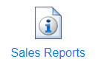
You can download a report of everyone who has got a ticket using the Sales Report Tool

Here is an example of one of our DSU events with a free ticket.
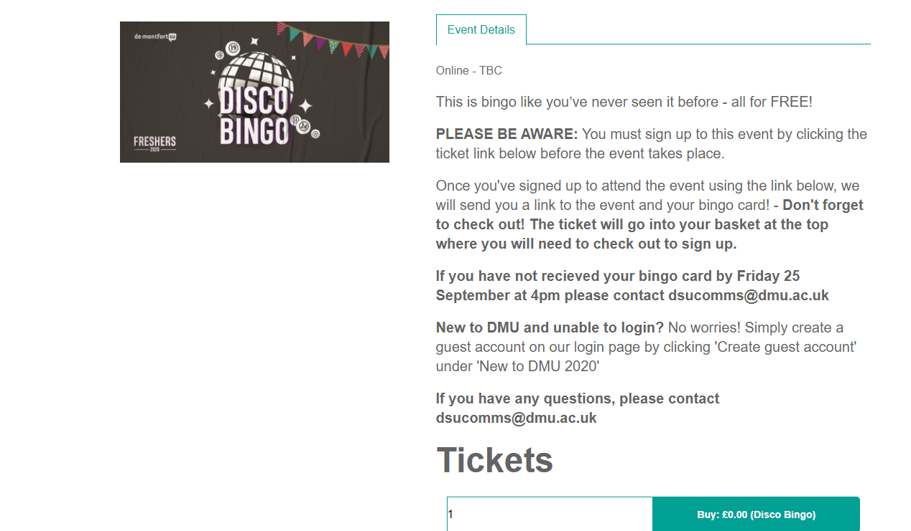

Prior to your first meeting review your chosen online platforms best practiced and security to protect your meeting.

Find out how you can do the following:
- Remove unwanted or disruptive participants
- Disable video- This will allow hosts to block unwanted, distracting, or inappropriate gestures on video.
- Mute participants- In case you need to mute everyone because of background noises etc.

Tips for hosting online meetings
- Nominate someone who is not the host to monitor the in-meeting chat.
- Make sure you’re not sitting with your back facing a window as people won’t be able to see your face properly
- Try to find a quiet area
- Ask that everyone mutes their microphone is they aren’t speaking to minimise feedback, echoes and backgrounds noises.
- Wear headphones with a built in microphone so people can pick you up more easily
- If you using headphones, make sure the microphone isn’t too close to your face otherwise your breathing will be very distracting (wind noises)
- Try to have a strong internet connection, if your internet is poor turn your video off and incoming video and just use audio
- If you can’t find a blank wall, add a background effect like blur
- If you will be sharing content during the meeting, make sure you have the files and/or links ready to go before the meeting begins.

Well done on adapting your student group to be active in a virtual platform. If you need any more support or guidance, or you would like to share some advice to pass on to other groups, get in touch with activities@dmu.ac.uk .

