Creating A Give it a Go Event Online!
- To create an event, you will need to your groups Admin Tools. To access these, go to your society page on the DSU website and make sure you have logged in (top right-hand corner using your single sign on).
- Once you are logged in, there should be a tab along the bottom of the webpage with ‘page admin’ in the bottom right corner. Click on ‘page admin’ which will show you a list of pages. Click on ‘YOUR GROUP Admin Tools’ (see below):
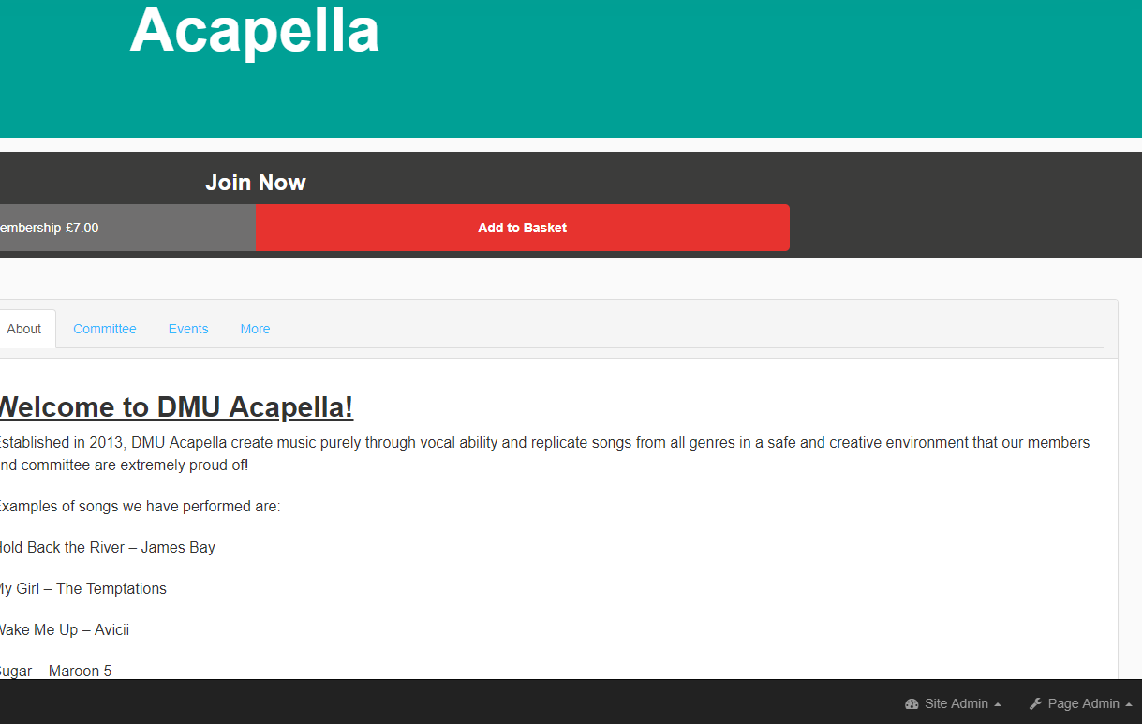
Select your student group’s admin tools
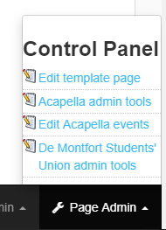

- A page similar to this will appear (some permissions you may not have – will depend on your committee position – see below)
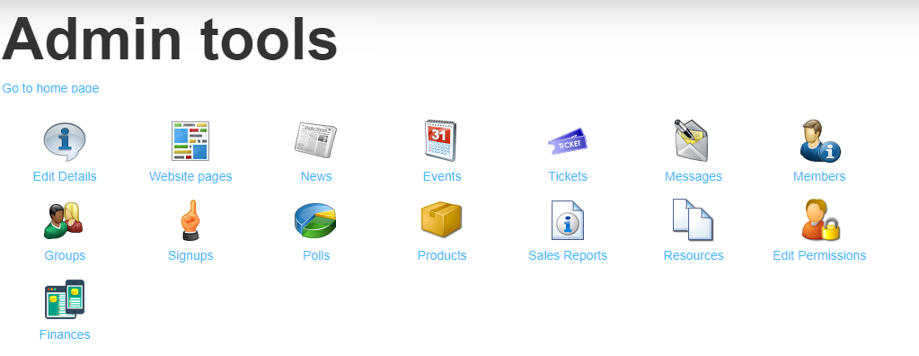

- To create an event for your student groups, including your Give it a Go Session, you will need to click on the ‘Events’ Area.
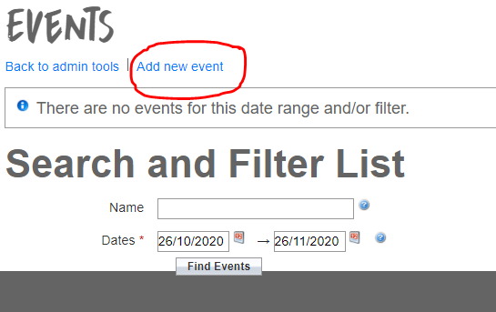
- Once you have clicked into the Events Area, a page with all your events will appear. If you have not set any events up online, this page will be blank. You need to click on the ‘Add New Event’ in the top left-hand corner (see below):

- The Add new event page will provide you with a form to complete, including the name of your event, date and time of your session, a description of the event, image and any other important information.
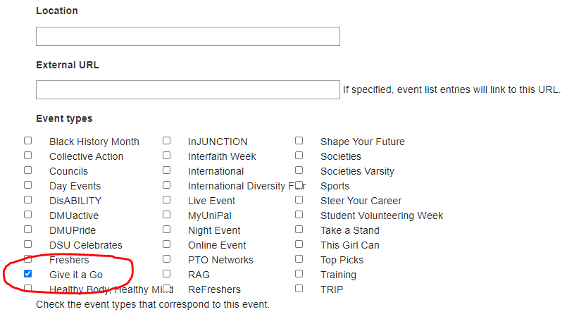
- Please ensure that you select the type as ‘Give it a Go’ and ensure this is ticked in the small box so the event appears on our page (see below):
- After completing the form, click ‘Save’ and this will add the event to the DSU page!

